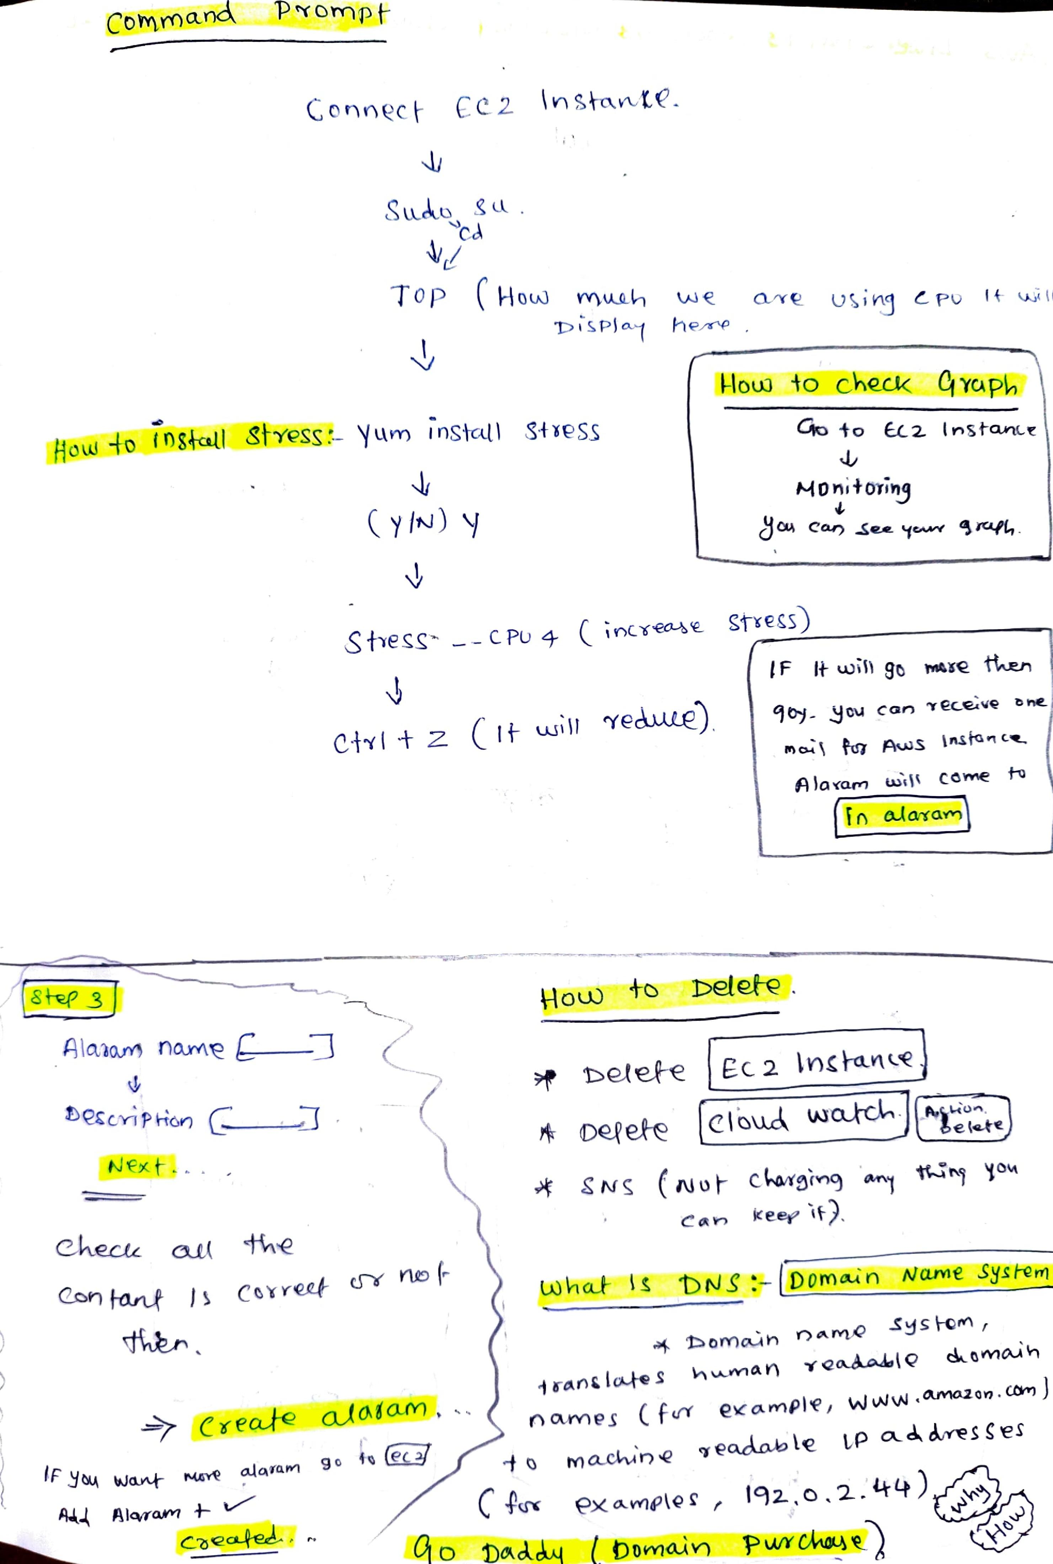

cl/vv_

**YvNkkil. k PI**

we

he/eV

u%;Pli 'pt.)14 **Q1/4,i**

1

St YcSS

HoW **40 nS#C41 S1Y9SS t i**

**krn nS•Ckti**

***C* ca *r-)* oxecc:ove b**

I cu

**insitin (AL COvvie f-a**

**m 0-Z j rt%bl**S

**'awn Isis**

**C Pu**

S cs-

I z C tks;11 erec)L1ALD

tb.e.teq-e

Ec **2 tnSitmv42**

**eta-4-e**

Pi, et-Q tAlcad^

***4 g 14c (Alt 6.0.45ryn owl it.: hi***

***e ay" Kew ,***

3'3'4

***I F*** 3NA **Want Mire?**

*ur*ea o1/4) g

90 4,1 4

Comrnana P ornp t-

C cnvWc (l C %,-) Skc■o. tc.

#t, Delete .

whcd S tiNS FDomain ivarne Sys he

**41, Ic=■orrhx.:0-1 r)okrvv(?**

**i ran& 10-ke co,A.n.A,,t47**

**narelps C *fcrY*** *ex cirnplv w ohm ouvutIon* **(to)**

**rnactlAsn‘e ryeckALvt°1.€ LP ax-4 Ar*, s**

C**Tor e5C. ckridAQ e 192 ,**

**ID"-ckA4 t) Dr e/C6 Cictim**

C kecte_ *cUR* *ye

CcNn fri,ut ***Gov)(CO- crY***

Sfi~**e**

A lalcur, ncurA

t2c c-y-; p hidr7 **C-111**

**t■J'Ex ,**

***Alevrwrn 4-***

***C.-45,2044-6A-*** *r* **P.**

F If LoiS1 9p tivaite 1-1".e.r1

__J

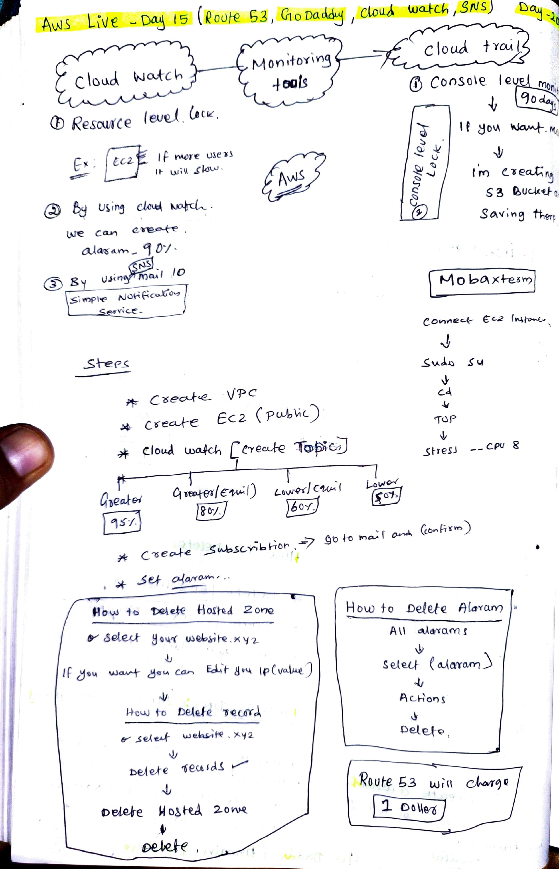

LA **0 lc,01X4--eacre7**

**we *Carl***

***CAAcrtSttvrN 01***

***u.k-in* rf) CLA I**

**- *0***

***-irewlge* ot4 *E;cc..Vc),/***

*cw.:(* X6 o4

J)

**A,**

**TIV■IS** L**IVE — Da6 15** (Poore G 3 , 0 Da aciAj aok.6, watai ,,qNs)

-zo

**.Sees**

*VP* c

czrec-O-e ec (P"")

***.* Cloutt wakti Cervect4-e Tap;)-C..-D**

CI wee-11911e

**it C. -Isea-4- ..-500.scv-16k;or7 9-0 4-0**

P

**6**

**Now to tlet 11011-04 tore**

***Seteck 8ow1( useios-4-,e 9“ 12_***

F jug, ca"

1i

Pow to **behfe .peusTA**

**.seArd4 *weAl.k;K >1/4V2 be/10'C* feu,** v511

1

**Ciete4re W** 0m-a Zone

Deipae

'non,

cloud +YGU(

**COnSo0a iev**

9

**t Dvi wcv.A4-.**

(1) Reseula e euci **bate.**

**J**

**4., -V**

**--. ,)**

,4) **....) ,**

**■**

**0 1 rn CI ea 1\J**

**j**

**L.,**

**S 3 Cucito,,,.**

**SCW;v19 ftit.rt**

**Covw,ec-er c-c.2**

**SvJAI *s***

cd

**70P**

**st-resi co/ 8**

a;-L+ (bytritim,)

*eakei*

**8.4 le(vatut)**

F **niae users** it **'**Ski

ggy us ng *do\** **NalcCi"-**

e3

|  |  |  |
| --- | --- | --- |
|  | Q.( |  |

?ir • Oliob0-1 Balcal cS ta-6■AC..c

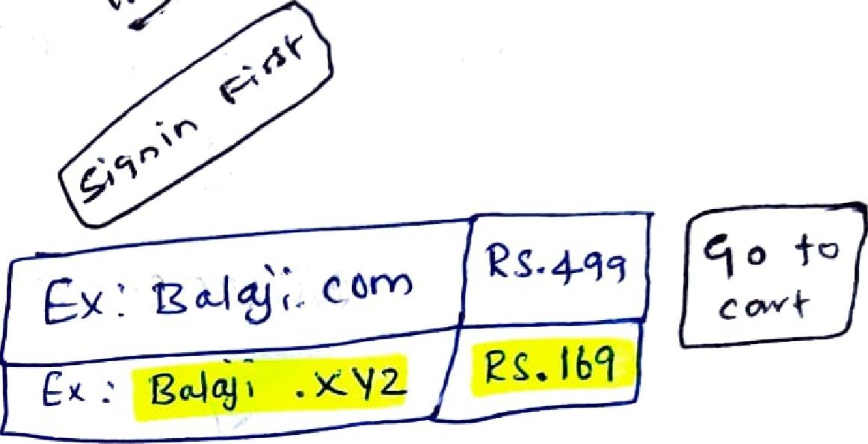



qua Own liebsd-e 2—

io 9001e •

,g)c(Y\

*Oro* backckj



**search 80u t DOM6A**

v1

rU' ckfiusv cR Tel 0"P( e evw:vcQ-Amx'ut ,

|  |  |
| --- | --- |
| How 4-0 cieake 1-1os Fed zonQ gc.-  Gro +0 "Rou.,i-e 3  c ri-e(A 2--once |  |

Hosi-ed zonie Con VI qwleutitv)

Dovna:4 neLvvvQ

|  |  |
| --- | --- |
|  | **VALt- 1. Cr ea-i- Ri**  **Packitli** |

t)c)cIfirrion r opt--+ *60c*

PAIS

_2) *SCA*

s"Pu-bii-c 0 pIlvekt-ie .

Ida R04,2 *Trcf(--*l zel„

|  |  |  |
| --- | --- | --- |
| 4 w;i1 cIectic | P..c *c* Ifdk |  |
|  |  |

(Lle



|  |  |
| --- | --- |
| qo 4-0 CtoPck,tcty  Naryw ea-v s Cc 1,0,1(1  nam eS'encve^c _s 10A | C2-  g***A* c6.1 KickolE eskto.** |
|  |  |
| **••+.-c** e , |  |

|  |  |  |  |  |  |  |
| --- | --- | --- | --- | --- | --- | --- |
|  |  |  |  | Naryye *s* gyver'‘  \Pes  *C On* i-inwp  **D 1-0** Poo-e  Tec-oi .  \Pi  e cotid nourew |  |  |
|  |  |  |  |  |  |
| Next- — | | |  |  |  |
|  |  |  |  |  |  |
|  |  |  | - | \t)  p e c o-YA Tkipe  tA-4 Ocatik ***vt'') ay, \ eq.*** add rPS-C  *""-c'e's*  *Aug* | | |

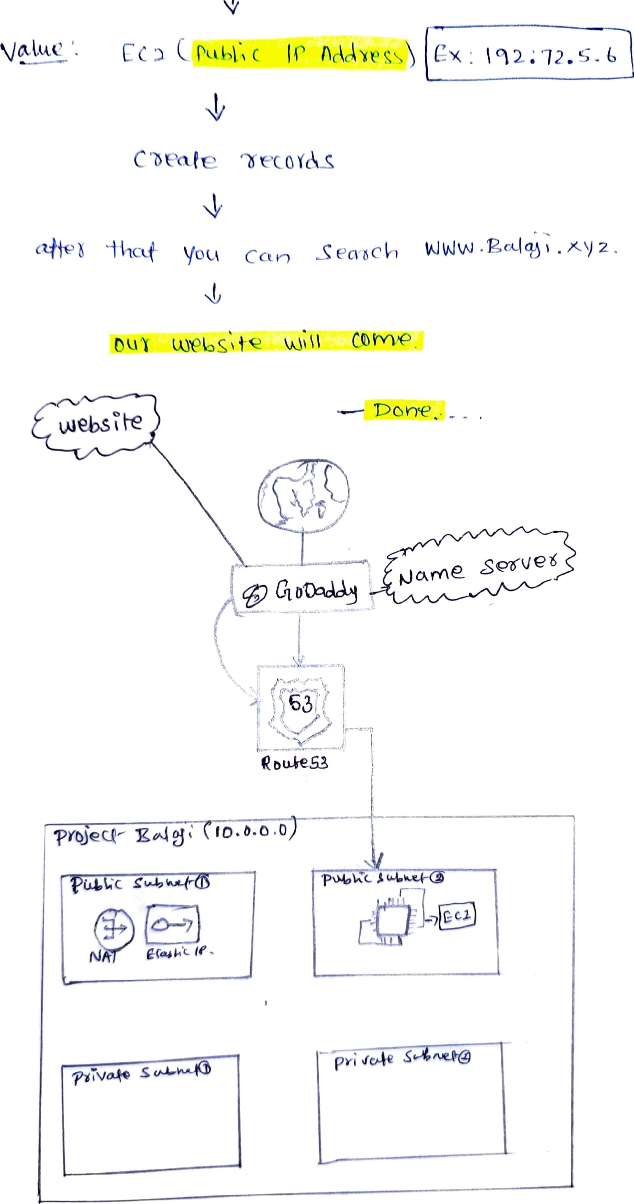

**• M 2**

V

\jettac cc P c

eZtiate eirticof&S

ailvt you Can Secci VJW‘N .gotieg"

**--- 1).0** rre _ _

**webs t-e**

**rwit**

'ill■■■■■■••■•

11212-c- t]

tul aye6si-c? kkco1 **ClbirYVP**

***)****3****(***

Lore

**rFrial;c_ ha+.**

**___---_---Tr-r-i**

**S6-11°'Ve-Pg**

IC **ilAchms**

**retie“- E.eAi 6; *00.0.0.0***

**uttic
  
N *E-GukL re***

**rii'votko s**